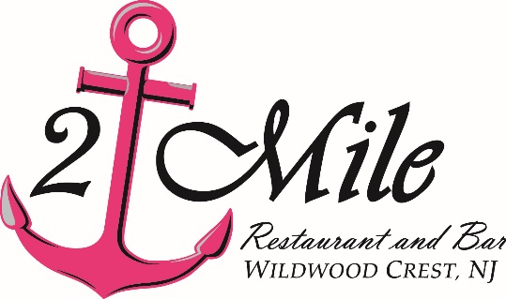

3-Course Easter Dinner Menu $45 per Person
Soup or Salad (choose 1)
Lobster Bisque, New England Clam Chowder or Asparagus Bisque with Crab or
Caesar Salad or Spring Garden Salad with Balsamic Dressing
Entrée (choose 1)
Seared Cape May Scallops
Day-Boat Cape May Scallops over Gnocchi in a Garlic & Lemon Spinach Cream Sauce
Avocado & Crab Stuffed Flounder
Local Flounder Wrapped around Avocado & Crab Imperial, Lemon Butter Sauce;
Garlic Mashed Potatoes & Chef’s Vegetable
Roasted Halibut
Topped with Crabmeat in a Lobster Sherry Cream Sauce;
Garlic Mashed Potatoes & Chef’s Vegetable
Jumbo Lump Crab Cakes
Roasted Red Pepper Drizzle; Garlic Mashed Potatoes & Chef’s Vegetable
2 Mile Filet Mignon
Caramelized Onions and Blue Cheese Crust, 3 Peppercorn Demi-Glace; Garlic Mashed Potatoes & Chef’s Vegetable
Broiled Seafood Combo
Shrimp, Cape May Scallops, Fish, Stuffed Clam & Crab Cake, Twice Baked Potato Cup & Chef’s Vegetable
Dessert (choose 1)
Chocolate Mousse, Warm Bread Pudding with Caramel Sauce,
Brown Butter Cake with Fresh Berries, New York Style Cheesecake
Chocolate Dream Brownie & Ice Cream

