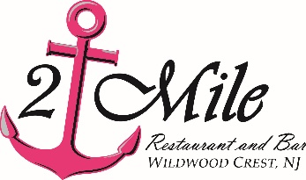
Happy Mother’s Day
Pre fixe Menu $35

First (choose 1)
New England Clam Chowder, Lobster Bisque, Spinach Salad or Caesar Salad

Second (choose 1)
Crab House Broiled Seafood Combination
shrimp, scallops, crab cake, fish & stuffed clam; twice-baked potato cup & chef’s vegetable
Jumbo Lump Crab Cakes
pan-seared jumbo lump, roasted red pepper drizzle; garlic mashed potatoes & chef’s vegetable
Filet Mignon
6 oz. center-cut filet over 3 peppercorn demi-glace, crusted with caramelized onions and gorgonzola;
twice-baked cheddar potato cup & chef’s vegetable
Salmon Oscar
seared Atlantic salmon, jumbo lump crabmeat, lemon béarnaise; garlic mashed potatoes & asparagus
Shrimp & Crab a La Vodka
shrimp, Cape May scallops & jumbo lump crabmeat in a vodka cream sauce served over penne pasta
Macadamia Nut Mahi-Mahi
macadamia nut-encrusted Mahi topped with coconut shrimp, mango brown butter, tropical coulis dipping sauce; coconut rice & chef’s vegetable
Orange Crush Shrimp
jumbo shrimp flamed in orange vodka butter; coconut rice & chef’s vegetable
Blackened Chicken & Broccoli Alfredo
creamy alfredo sauce, fettuccine
Fried Seafood Basket
panko-breaded jumbo shrimp, Cape May seabass & Cape May scallops; fries & coleslaw

Dessert (choose 1)
Chocolate Mousse
Caramel Bread Pudding
Blackberry Cheesecake
Key Lime Pie

